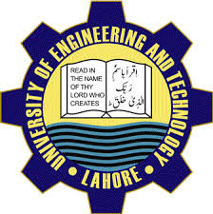  - Welcome Party  UET  Event Description Heading  Kick off the semester with new vibes, new friends & have fun at this welcome party whether you are here to grab some food & play some games. This is the perfect opportunity to start your university journey.
  Orientation
  ____
  Food Stalls
  ____
  Fun Activities
  ____
  Networking
  ____
  University Tour
  Uet MAIN Campus
  Department
  Of CS
  Uet.edu.pk
  Lahore

